SWOT Analysis of current website June 2026

Heading | Resources and Key Insights Section | Content and Copy Right Section
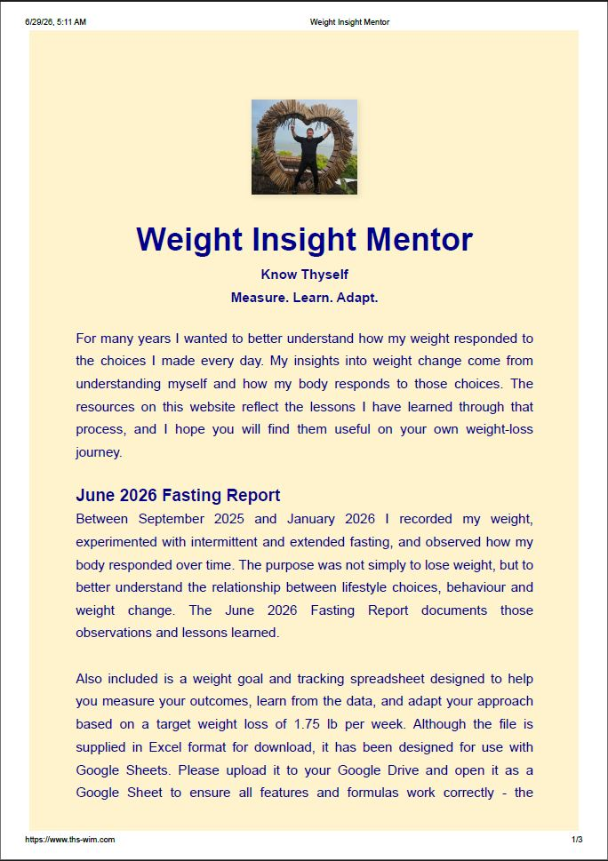 | 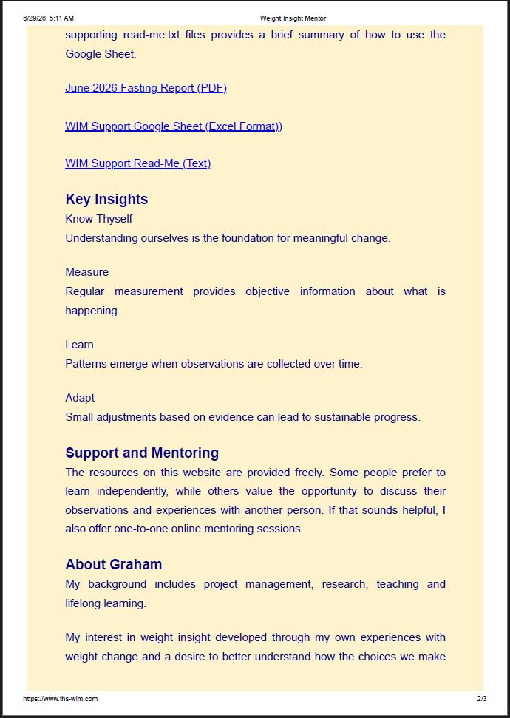 | 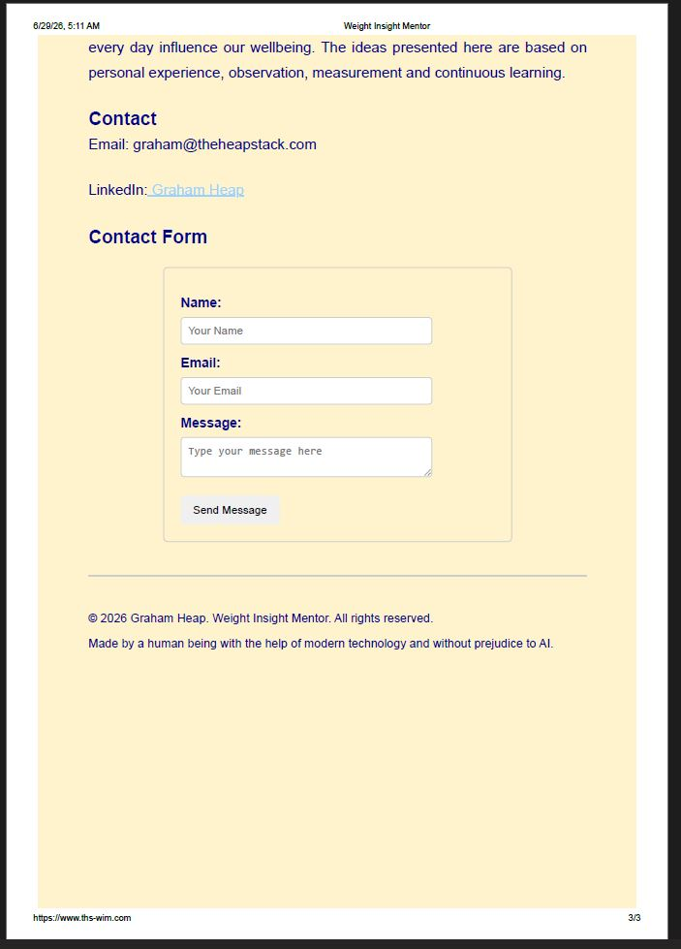

Table (1.0) : Summary of content of the current WIMS Website.

1.0 Current Website Summary
The current WIMS website provides an introduction to the Weight Insight Mentor (WIMS) service and the resources available to support users on their weight management journey.
The website currently contains:
- A heading with a photograph of Graham taken in Kenya, representing fitness and wellbeing.
- The four key insights from the fasting report:
  - Know Thyself
  - Measure
  - Learn
  - Adapt
- A brief summary of Graham's personal weight-loss journey and the factors influencing weight change.
- An introduction to the available resources and the aspiration to support users and clients throughout their weight management journey.
- A summary of the June Fasting Report.
- A downloadable weight goal and tracking spreadsheet together with supporting documentation explaining each worksheet and how the spreadsheet should be used.
- A description of each of the four key insights.
- A description of the additional mentoring service.
- A brief introduction to Graham.
- Contact details including email address, LinkedIn link and contact form.
- A footer containing copyright and source information.

2.0 SWOT Analysis

Strengths

The website provides an authentic personal story supported by practical experience and downloadable resources. The key messages of Know Thyself, Measure, Learn and Adapt provide a consistent philosophy throughout the site. The inclusion of reports, spreadsheets and mentoring information demonstrates credibility and supports users wishing to manage their weight through measured self-improvement.

Weaknesses
The website contains a large amount of text which may discourage first-time visitors. The emphasis is currently on downloadable documents rather than interactive services. The mentoring service is introduced but could be given greater prominence. The website functions primarily as an information repository rather than as a service-focused platform.

Opportunities

The website can be developed into a complete weight management service offering mentoring, structured programmes and additional educational resources. Future developments may include interactive tracking tools, video content, product reviews, community support and additional digital resources. The website can evolve from providing information to delivering an integrated mentoring service.

Threats

There are many established weight-loss websites and online services competing for attention. AI-generated health information is becoming increasingly common and may reduce differentiation unless the WIMS service clearly communicates its evidence-based and personal mentoring approach. Care must also be taken to ensure that all health-related information remains appropriately presented and does not imply medical advice.

3.0 Summary

The current WIMS website provides a solid foundation by presenting the philosophy, supporting resources and mentoring service in a clear and structured manner. The next stage of development should focus on evolving the website from a document-based information resource into a professional service platform that supports both the WIMS project and the long-term delivery of the Weight Insight Mentor service.

Web Stats for June 2026

For example:
Strengths | Evidence
Early public interest following launch | 374 unique visitors and 476 visits within the first 18 days.
Visitors engage beyond the landing page | 1,137 page views (2.38 pages per visit).
Supporting resources are being accessed | The Fasting Report PDF was requested 51 times, indicating interest in supporting documentation.
Search engines have already indexed the website | Traffic recorded from Google, Bing, Yahoo and Baidu.

Weaknesses | Evidence
Limited historical data | Statistics cover only the first 18 days of operation.
User engagement metrics are immature | Average visit duration is 42 seconds and requires monitoring as the service evolves.
Reliance on direct traffic | Over 94% of visits originated from direct links rather than organic search.

Opportunities | Evidence
Increase organic search traffic | Search engines have already begun indexing the site, creating opportunities to improve visibility through additional content and search optimisation.
Expand downloadable guidance | Early interest in the PDF report suggests that educational resources are valued by visitors.
Use analytics to guide service development | Website usage patterns can help prioritise future enhancements and content.

Threats | Evidence
Automated internet scanning | A large number of robot visits and 404 requests demonstrate the need for ongoing security monitoring.
Difficulty sustaining visitor growth | Early interest may decline without regular updates, promotion and continued service development.
Dependence on external search engines and social platforms | Future traffic levels may be influenced by changes in search engine indexing or social media visibility.
This is actually quite a nice piece of evidence because your SWOT won't just be based on opinion. It will combine:

- The project definition.
- Your professional experience.
- Literature review.
- Measured website analytics.

That makes it a much stronger and more defensible SWOT analysis. As a PMP, I know you'll appreciate that it's evidence-based rather than speculative.

